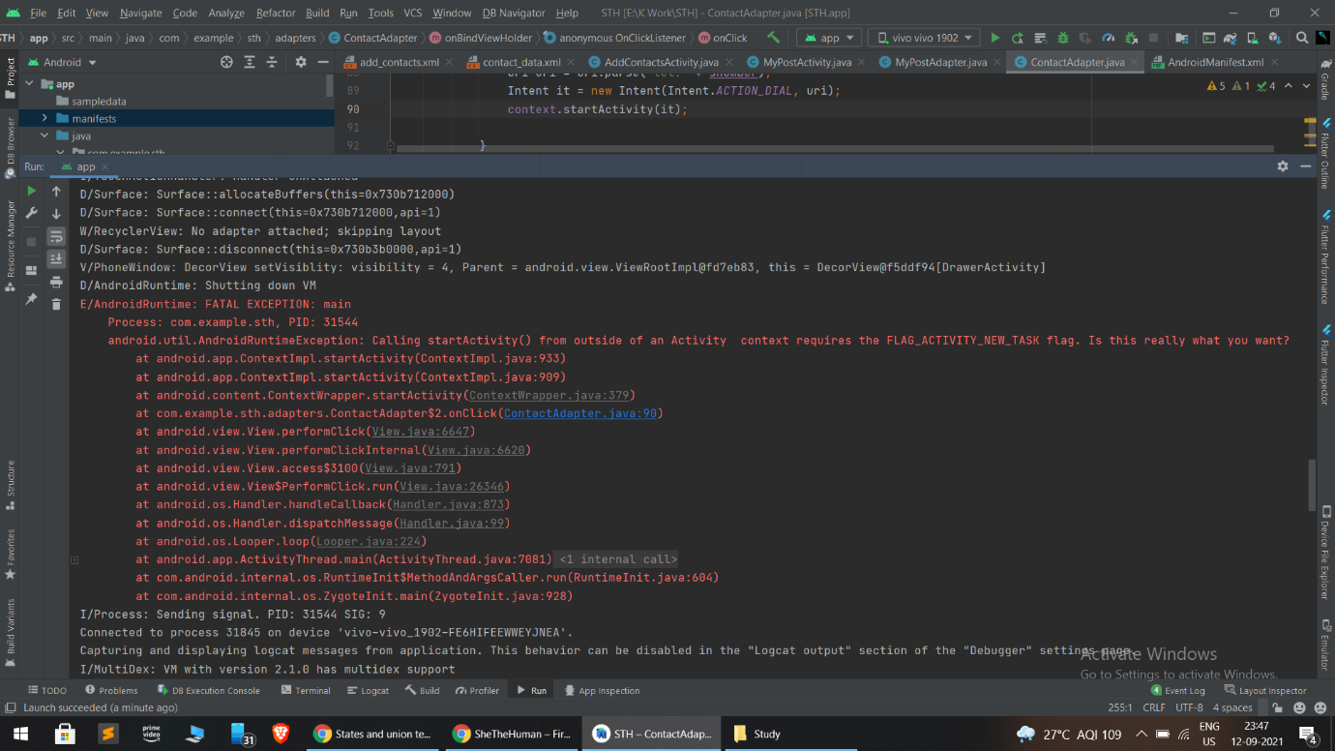

This is error is generated while sending value from ContactAdapter.java file [This is adapter java file which is used for handling contact related files such as storing and displaying data]. This error shows that we have to add flag in intent named as “FLAG_ACTIVITY_NEW_TASK”. While setting this flag, the activity is able to start new task on his history stack.

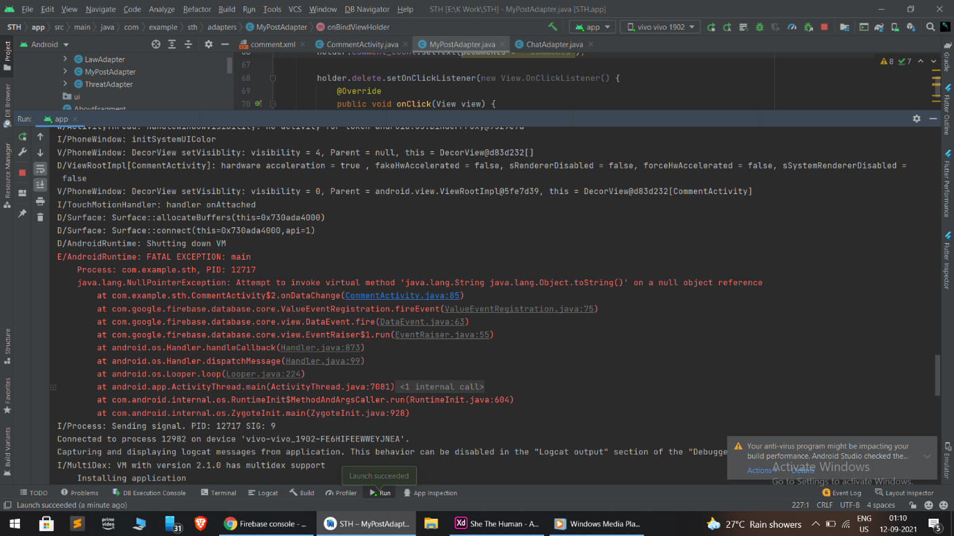This error is generated, because the refence which is given to show comment, is null. In other words, the the data which we are trying to retrieve from database is null or the name of that field is not found.

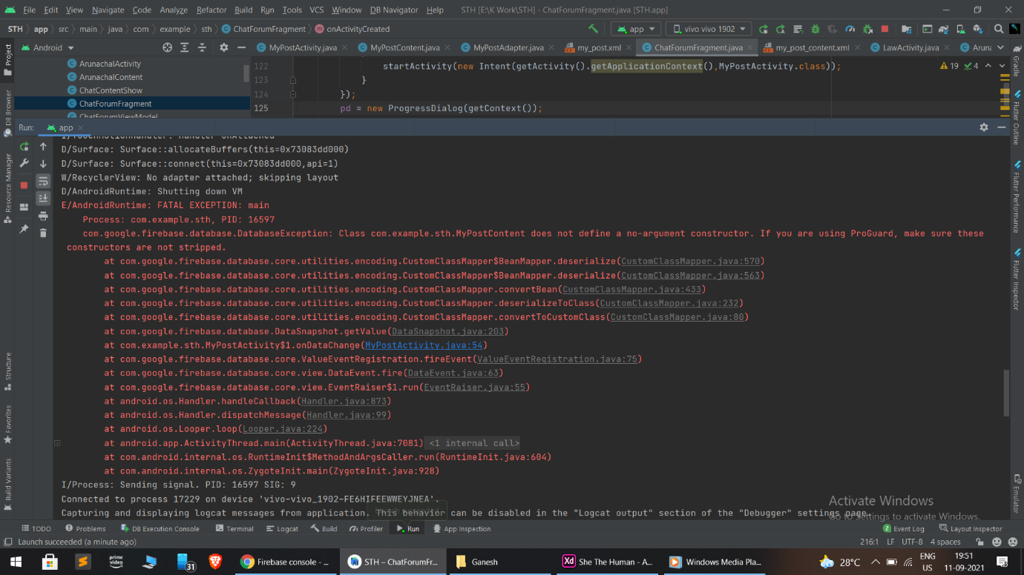

This error is generated because the java file named “MyPostActivity.java” [This is the file which handles and display the current user’s post] required empty constructor also to handle the activity because firstly there are no posts uploaded by the user.